eSlide Manager User Guide
eSlide Manager is the new digital pathology information management system developed for advanced visualization of digital slides and workflow management. eSlide Manager replaces Spectrum. Please email histoimage@purdue.edu with additional questions.
https://aperio.vet.purdue.edu/Login.php

Logging in to eSlide Manager
- Please only use Firefox or Internet Explorer web browsers for optimal application of eSlide Manager. The eSlide manager program has some known incompatibilities with Chrome and Edge.
- Your log in is your Purdue Career Account User ID and password, for both on and off campus.
- Please choose a role. Your role will determine what permissions you have for viewing slides. Your role is defined by the System Administrator (Dr. Durkes) and may be changed upon request.
  - Education roles
    - Course Leader = Professor of record
    - Course Instructor = Instructor
    - Student = Student in a course
  - Research roles
    - Research Group Leader = Principal investigator
    - Researcher = Lab members other than PI
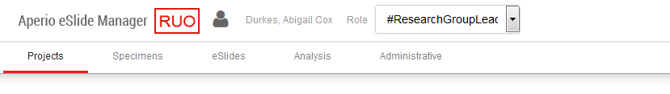
  - Along the top of the page you will see a drop-down box that reminds you what role you are currently using.

eSlide Manager Data Organization
- Data hierarchy for RESEARH

  - Data Groups: categorize data by user and are usually named by PI
    - Data groups classify similar data into categories so users can be given access to a particular category of data.
    - Access to data groups is determined by the role and permissions of an Aperio user
  - Projects: typically are one study within a lab
  - Specimens: varies with the researcher, but may be a particular animal, treatment group, collection day, stain, etc.
  - eSlides: individual digital slides

- Data hierarchy for EDUCATION

  - Data Groups: categorize educational materials by user and are named by course number (e.g. CPB 851)
    - Access to courses/data groups is determined by the role and permissions of an Aperio user
  - Course: can be divided by semester and year
  - Lessons: Multiple lessons within a course
  - Specimens: but may be a particular animal, organ, stain, etc.
  - eSlides: individual digital slides

Navigating the main page
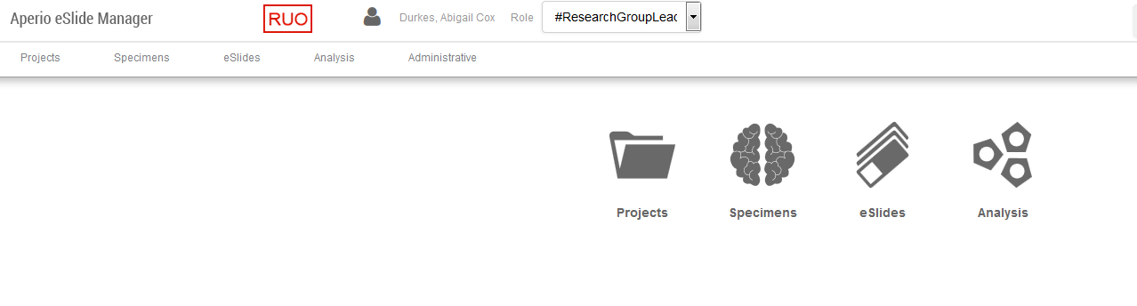
RESEARCH
Logo
Data icon
Menu bar

EDUCATION
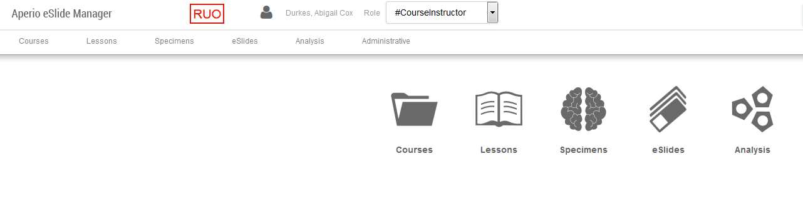
Logo
Menu bar
Data icon
- Logo – use eSlide Manager logo to return to the main page at any time
- Menu bar – helps you use special eSlide Manager features and access data in different ways
- Data icons – used to access the information and images stored in eSlide Manager
- As you open Data icons at different levels of the hierarchy, the data table for that particular icon will expand vertically down. You can scroll down to see all the data that is open.
  - To minimize data in a Data Icon list, simply click on the red arrow beside the icon
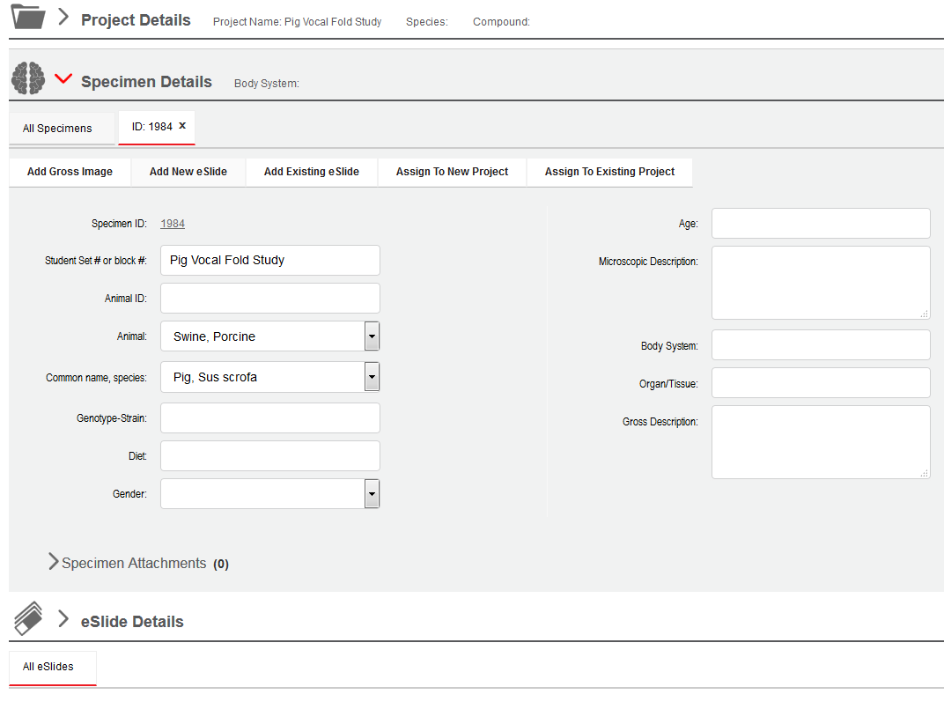
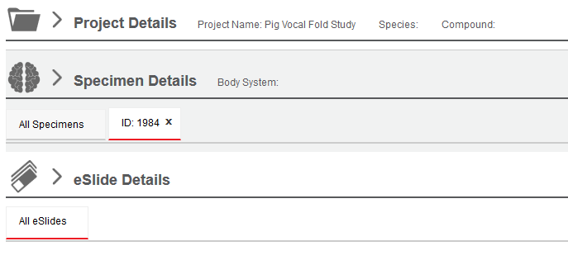
  - Not expanded vs. Expanded
NOTE: this example is for RESEARCH data but is also applicable to EDUCATION data.

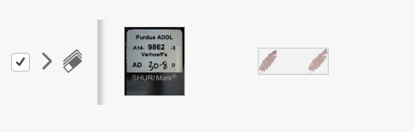
- Under eSlide Details at the bottom of the expanded page you can check a specific slide and then click on Open Data under the eSlide Details.
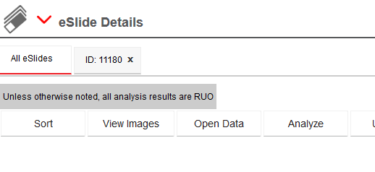
- This will open a separate tab of eSlide Details for that particular eSlide image.
Separate tab

Viewing Images
- Click on the data icon Projects/Courses
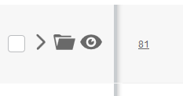
- Click the folder to the left of the Specimen/Lesson of interest to expand the details OR click the eye icon to open all eSlides of that specimen/lesson in the eSlide web viewer.
- Alternatively, you can access images from the Specimens data icon
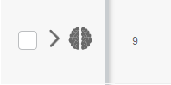
  - Click the brain icon to the left of the specimen of interest
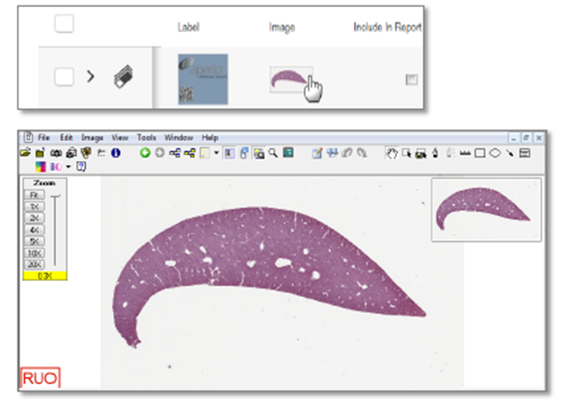
  - Click a thumbnail to open the image in Image Scope OR hold the W key while clicking the image thumbnail and the image will open in the new web viewer.
Review eSlide images with the Web Viewer
  - To open images in the Web Viewer, click the Eye icon or hold W key while clicking on the image.
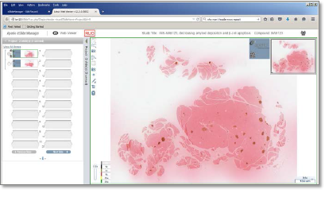
  - The virtual slide tray is on the left and the slide image and annotation tools are on the right. The eSlide tray simulates an actual slide tray.
    - The eSlide you’re currently viewing has a dark border around it.
    - When you navigate around the slide, the Web Viewer flips the slide in the tray so the label is on the right.
      - Label on the left = Unread
      - Label on the right = Read
    - To change an eSlide from Read to Unread, right click the eSlide and select Toggle Read/Unread. The slide in the tray return to Unread status.

